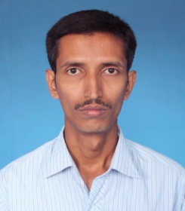

Career Objective

Experienced Computer Lab Assistant who is proficient in all major operating systems. Adept at database analysis computer troubleshooting and upgrading hardware and software.

Educational Qualification

* Master in Computer Application (M.C.A), Annamalai University-2015 [67%]
* Bachelor in Computer Application (B.C.A), Madras University – 2010 [57%]
* Advanced Diploma in JAVA Programming (ADJP), Computer Software Collage (CSC)

Technical Skills

|  |  |
| --- | --- |
| **Skill Set** | **Description** |
| **Programming and Scripting Languages** | VB 6.0, VB.NET, Java, C, C++, HTML |
| **Database** | MS-Access , SQL |
| **Operating System** | MS-DOS & Windows XP |
| **Graphics tools** | Adobe Photoshop, Adobe PageMaker, CorelDraw. |

**Working Experience**

Trainer (Tutor) and Center-Incharge in CSC Computer Centre, Villupuram, (Jun 2015 to May 2019)

**Personal Details**

**Father’s Name :** Abdul Hafiz

**Permanent Address** : #15, Azeez Nagar,

Mambalapatu Road,

Villupuram,

Tamilnadu-605 602

**Date of Birth :** 20th November, 1980

**Gender :** Male

**Mother Tongue :** Urdu

**Marital Status :** Married

**Language known :** Tamil, English, Hindi & Urdu.

**Place:** Villupuram Yours Thankfully

**Date:**

**Abdul Azeez**